The British Burn the White House

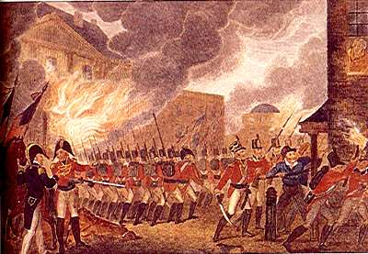
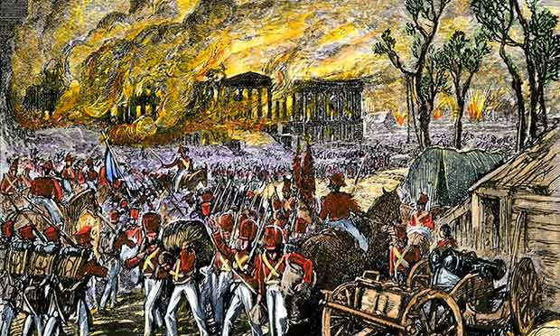
1. Picture yourself in the scenes above, as an American civilian, watching British soldiers burn the White House and other buildings in your nation’s capital. What would you be thinking? How would you feel?

2. Why do you think the British burning the White House helped develop a sense of national identity amongst Americans? Can you think of a more modern example of an attack on the nation that brought people together?
Battle of New Orleans
"Col. Smiley, from Bardstown, was the first one who gave us orders to fire from our part of the line; and then, I reckon, there was a pretty considerable noise... Directly after the firing began, Capt. Patterson, I think he was from Knox County, Kentucky, but an Irishman born, came running along. He jumped upon the brestwork (sic) and stooping a moment to look through the darkness as well as he could, he shouted with a broad North of Ireland brogue, 'shoot low, boys! shoot low! rake them - rake them! They're comin' on their all fours!'
...It was so dark that little could be seen, until just about the time the battle ceased. The morning had dawned to be sure, but the smoke was so thick that every thing seemed to be covered up in it. Our men did not seem to apprehend any danger, but would load and fire as fast as they could, talking, swearing, and joking all the time. All ranks and sections were soon broken up. After the first shot, everyone loaded and banged away on his own hook.
Henry Spillman did not load and fire quite so often as some of the rest, but every time he did fire he would go up to the brestwork, look over until he could see something to shoot at, and then take deliberate aim and crack away.
At one time I noticed, a little on our right, a curious kind of a chap named Ambrose Odd, one of Captain Higdon's company, and known among the men by the nickname of 'Sukey,' standing coolly on the top of the brestworks and peering into the darkness for something to shoot at. The balls were whistling around him and over our heads, as thick as hail, and Col. Slaughter coming along, ordered him to come down.
The Colonel told him there was policy in war, and that he was exposing himself too much. Sukey turned around, holding up the flap of his old broad brimmed hat with one hand, to see who was speaking to him, and replied: 'Oh! never mind Colonel - here's Sukey - I don't want to waste my powder, and I'd like to know how I can shoot until I see something?' Pretty soon after, Sukey got his eye on a red coat, and, no doubt, made a hole through it, for he took deliberate aim, fired and then coolly came down to load again.
The battle
During the action, a number of the Tennessee men got mixed with ours. One of them was killed about five or six yards from where I stood. I did not know his name. A ball passed through his head and he fell against Ensign Weller...This was the only man killed near my station.
It was near the close of the firing....there was a white flag raised on the opposite side of the brestwork and the firing ceased. The white flag, before mentioned, was raised about ten or twelve feet from where I stood, close to the brestwork and a little to the right. It was a white handkerchief, or something of the kind, on a sword or stick. It was waved several times, and as soon as it was perceived, we ceased firing.
Just then the wind got up a little and blew the smoke off, so that we could see the field. It then appeared that the flag had been raised by a British Officer wearing epaulets. It was told he was a Major. He stepped over the brestwork and came into our lines. Among the Tennesseans who had got mixed with us during the fight, there was a little fellow whose name I do not know; but he was a cadaverous looking chap and went by that of Paleface.
As the British Officer came in, Paleface demanded his sword. He hesitated about giving it to him, probably thinking it was derogatory to his dignity, to surrender to a private all over begrimed with dust and powder and that some Officer should show him the courtesy to receive it.
Just at that moment, Co!. Smiley came up and cried, with a harsh oath, 'Give it up-give it up to him in a minute.' The British Officer quickly handed his weapon to Paleface, holding it in both hands and making a very polite bow. A good many others came in just about the same time.
...On the opposite side of the brestwork there was a ditch about ten feet wide, made by the excavation of the earth, of which the work was formed. In it, was about a foot or eighteen inches of water, and to make it the more difficult of passage, a quantity of thornbush had been cut and thrown into it. In this ditch a number of British soldiers were found at the close under the brestwork, as a shelter from our fire. These, of course, came in and surrendered.
When the smoke had cleared away and we could obtain a fair view of the field, it looked, at the first glance, like a sea of blood. It was not blood itself which gave it this appearance but the red coats in which the British soldiers were dressed. Straight out before our position, for about the width of space which we supposed had been occupied by the British column, the field was entirely covered with prostrate bodies. In some places they were laying in piles of several, one on the top of the other."
References:
This eyewitness account first appeared in The Louisiana Historical Quarterly, Vol. IX, No. 1, January 1926, republished in Angle, Paul, M., The American Reader (1958); Remini, Robert Vincent, The Battle of New Orleans (1999).
1. Describe the Battle of New Orleans in your own words.

2. How do you think the American soldiers felt during this battle?

3. How do you think the American soldiers felt at the end of this battle?

4. Why do you think the Battle of New Orleans helped develop a sense of nationalism for Americans?

